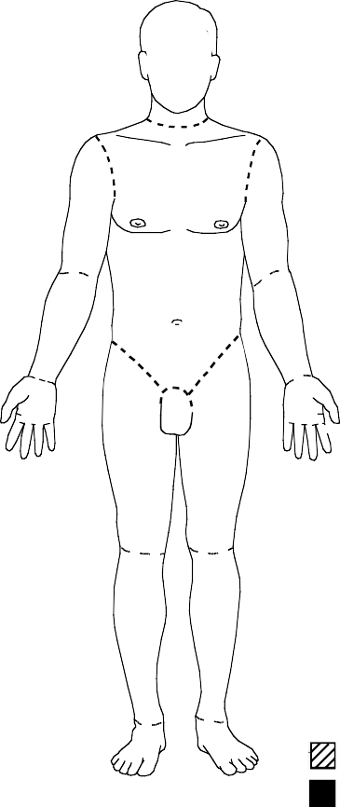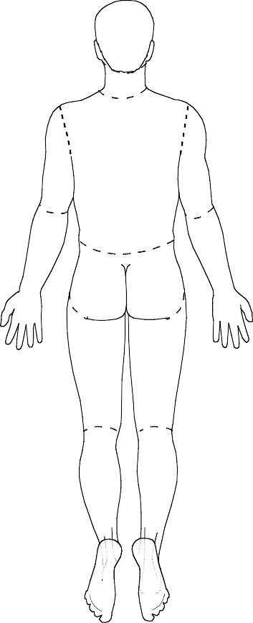
INITIAL
Burn Diagram

2nd Degree 3rd Degree

Burn Estimate and Diagram Form
Shriners Hospital - Cincinnati
866-947-7840

Name

Age

Date of Burn Time of Burn

Height (cm) Weight (kg)
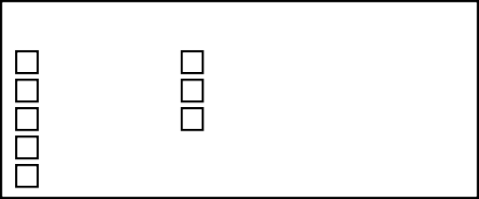
CAUSE OF BURN:
Chemical Inhalation Injury
Contact Electrical Flame
Scald
Other:

Questionable Circumstances

Area | Birth 1 yr. | 1-4  yrs. | 5-9  yrs. | 10-14  yrs. | 15  yrs. | Adult | Initial TBSA
 |  |  |  |  |  |  | 2° | 3°
Head | 19 | 17 | 13 | 11 | 9 | 7
Neck | 2 | 2 | 2 | 2 | 2 | 2
Ant. Trunk | 13 | 13 | 13 | 13 | 13 | 13
Post. Trunk | 13 | 13 | 13 | 13 | 13 | 13
R. Buttock | 2.5 | 2.5 | 2.5 | 2.5 | 2.5 | 2.5
L. Buttock | 2.5 | 2.5 | 2.5 | 2.5 | 2.5 | 2.5
Genitalia | 1 | 1 | 1 | 1 | 1 | 1
R.U. Arm | 4 | 4 | 4 | 4 | 4 | 4
L.U. Arm | 4 | 4 | 4 | 4 | 4 | 4
R.L. Arm | 3 | 3 | 3 | 3 | 3 | 3
L.L. Arm | 3 | 3 | 3 | 3 | 3 | 3
R. Hand | 2.5 | 2.5 | 2.5 | 2.5 | 2.5 | 2.5
L. Hand | 2.5 | 2.5 | 2.5 | 2.5 | 2.5 | 2.5
R. Thigh | 5.5 | 6.5 | 8 | 8.5 | 9 | 9.5
L. Thigh | 5.5 | 6.5 | 8 | 8.5 | 9 | 9.5
R. Leg | 5 | 5 | 5.5 | 6 | 6.5 | 7
L. Leg | 5 | 5 | 5.5 | 6 | 6.5 | 7
R. Foot | 3.5 | 3.5 | 3.5 | 3.5 | 3.5 | 3.5
L. Foot | 3.5 | 3.5 | 3.5 | 3.5 | 3.5 | 3.5
Total:
See Reverse for Fluid Resuscitation Guidelines
(Repeated Bolus Therapy NOT Recommended)

Modified 4/20 from SHC- C_Mktg Burn Est & Diag 10/16; reviewed June 2022



Burn Fluid Resuscitation Guidelines
Bolus ONLY for hypotension [SBP = 70 + 2 × age (years)]. Tachycardia is a poor marker of resuscitation in a burn patient.

Initial fluid resuscitation if burn estimated to be >10% TBSA:

Age/Weight of Child | Initial fluid rate & type (prior to burn size calculation)
≤5 years old & <10kg | 125mL/hr of D5LR
≤5 years old & >10kg | 125mL/hr of LR
6-14 years old | 250mL/hr of LR
>14 years old | 500mL/hr of LR
>14 years old | 500mL/hr of LR
Once estimate of burn %TBSA has been completed, convert burn resuscitation fluids as instructed below under “Burn Fluid Resuscitation”.

Burn Fluid Resuscitation TBSA < 20%:
- If < 20% TBSA, burn fluid resuscitation is not indicated. Discontinue IVF or decrease to MIVF unless otherwise indicated or patient unable to take PO.

Burn Fluid Resuscitation TBSA ≥ 20%:
- Start 2-bag resuscitation per the following:
- Bag 1: 3 ml x %TBSA burn x kg / 16 = ml/hr LR

• +/- Bag 2 if < 30kg: MIVF = ml/hr D5LW

